**the biography**

# **Chairman of Board of Directors**

# **And Managing Director**

**the biography**

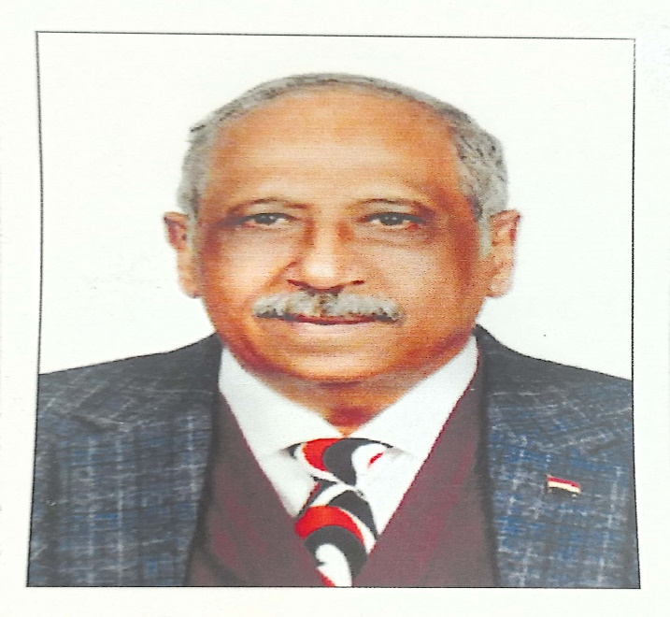

|  |
| --- |
| **Ahmed Morsi Mahmoud Salem**  **Chairman of the Board and Managing Director**  **Personal data :**  **Date of birth: 8/19/1948**  **Address: No. 2, Al-Hafiz Othman Street - Al-Ibrahimiyya**  **College: Commerce - Alexandria University**  **Egyptian nationality Languages: Arabic – English**  **communication**  **Mobile number:**  **01009922623**  **Means of communication:**  Email ;  Facebook ; Ahmed Salem |

|  |  |
| --- | --- |
|  | **First: Academic qualifications:** |
|  | Bachelor of Commerce - Accounting Division - May 1978 |
|  | **Second: Career progression:** |
|  | - General accounts accountant  - Commercial specialist, ship reception and travel  - Director of Personnel and Personnel Affairs  - Director of the Final Accounts and Planning Budgets Department  - Director General of Financial, Administrative and Commercial Inspection  - Head of the commercial sector  - Head of the financial sector  -Chairman of the Board and Managing Director |
|  | **Third:Training courses:** |
|  | - Computer 1984, Arab Academy  - Computer Programming 1970 I.C.L  - The art of negotiation at the Workers’ University  - Department of Personnel Affairs or Department of Human Resources  - Qualifying general managers and leadership positions  - English language 9 levels at the British Council   |  | | --- | | **Fourth:Administrative and supervisory positions:** |   - Director of Personnel and Personnel Affairs  - Director of the Final Accounts and Planning Budgets Department  - Director General of Financial, Administrative and Commercial Inspection  - Head of commercial sector  - Head of the financial sector  - Chairman of the Board of Directors and Managing Director   |  | | --- | | **Fifth: Scientific conferences:** | |

- All maritime conferences of the Arab Academy of Sciences

Technology and maritime transport

- All conferences related to cooperation with other countries

And held anywhere inside Egypt

|  |
| --- |
| **Sixth: Previous experiences:** |

- Chairman of the Board of Directors of Amoun Shipping

Agencies Company and Managing Director

- Commercial consultant at Amister Shipping Company.

- Chairman of the Board of Directors of the Arab Engineering

Trading and Contracting Company

- Vice Chairman of the Board of Directors of Memphis

Shipping Agencies Company

- He is currently Chairman of the Board of Directors of Abu

Simbel and Taiba Shipping Agencies Company